AWS Global Infrastructure
Infrastructure exists as the foundation of every cloud application.
Availability Zone:
An AZ consist of one or more data centres with redundant power, networking and connectivity.
A cluster of AZs called Region.
Choosing region- 4 aspects
- Compliance
- Latency
- Service availability
- Pricing
Data centres inside of AZs – AZ’s inside of regions.
Regions- Regions are geographic locations where AWS hosts its data centers. Each AWS Region is associated with a geographical name and a Region code.
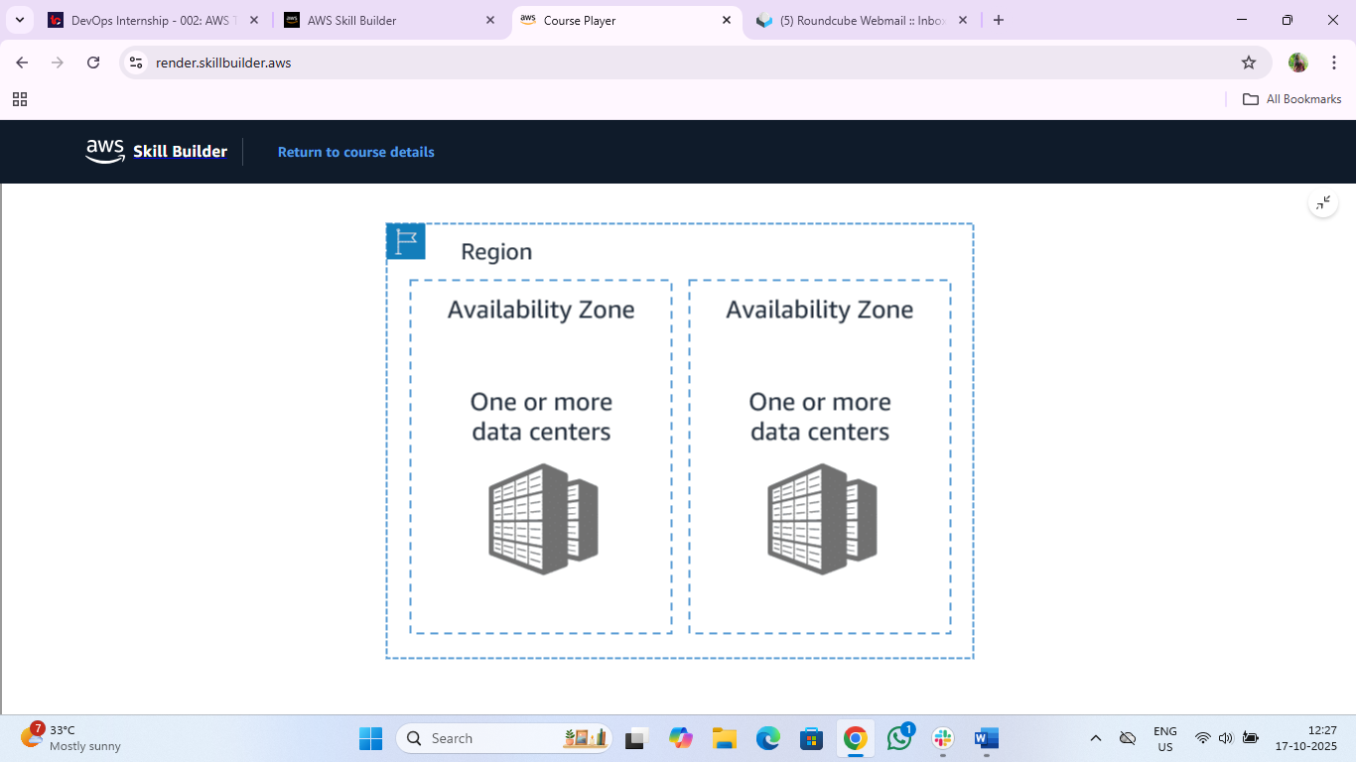
Edge locations: - are global locations where content is cached.
Resources
For more information, see the following resources:
- AWS website: Global Infrastructure(opens in a new tab)
- (opens in a new tab)AWS whitepaper: AWS Global Infrastructure Documentation(opens in a new tab)
- AWS website: AWS Regions and Availability Zones(opens in a new tab)
- AWS reference guide: AWS Service Endpoints(opens in a new tab)
- AWS website: AWS Regional Services(opens in a new tab)
- AWS developer guide: Amazon CloudFront

